Module 5 Project

Michael Rothbauer

Rasmussen College

Author Note

This paper is being submitted on December 9th, 2018, for Michael Rothbauer’s Advanced Mobile Web Applications.

Module 5 Project

Website link: http://sotd.us/michaelrothbauer/CIS%204655/Module%205/Project/mod5project.html

Repository: <https://github.com/michaelrothbauer/CIS4655C-Advanced-Web/tree/master/Module%205>

Images:

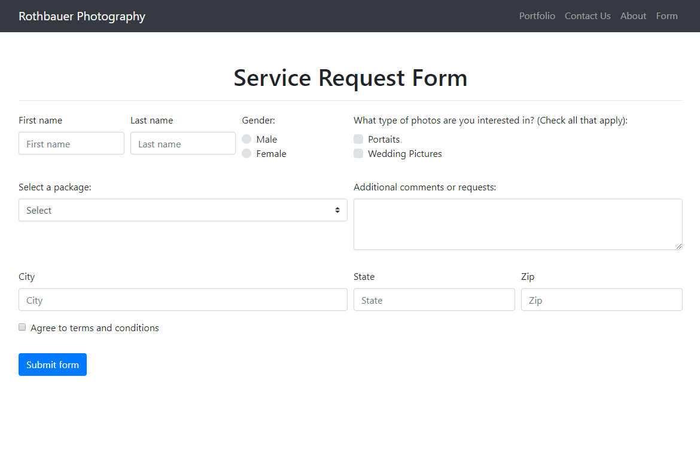

Galaxy S5:

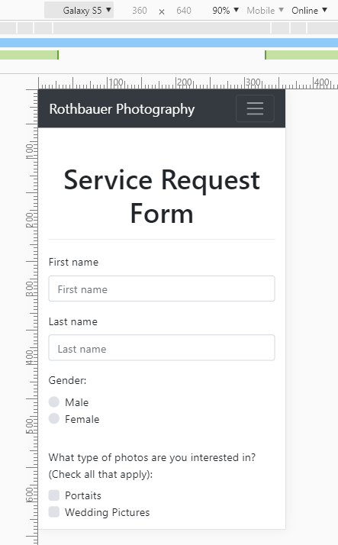

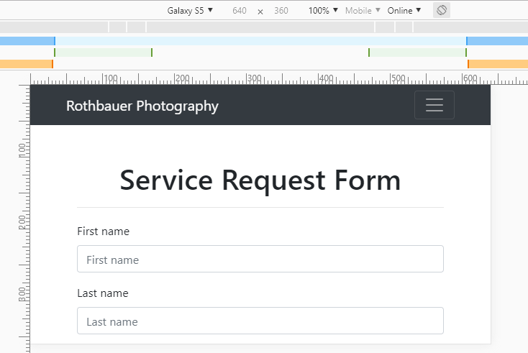

iPad:  
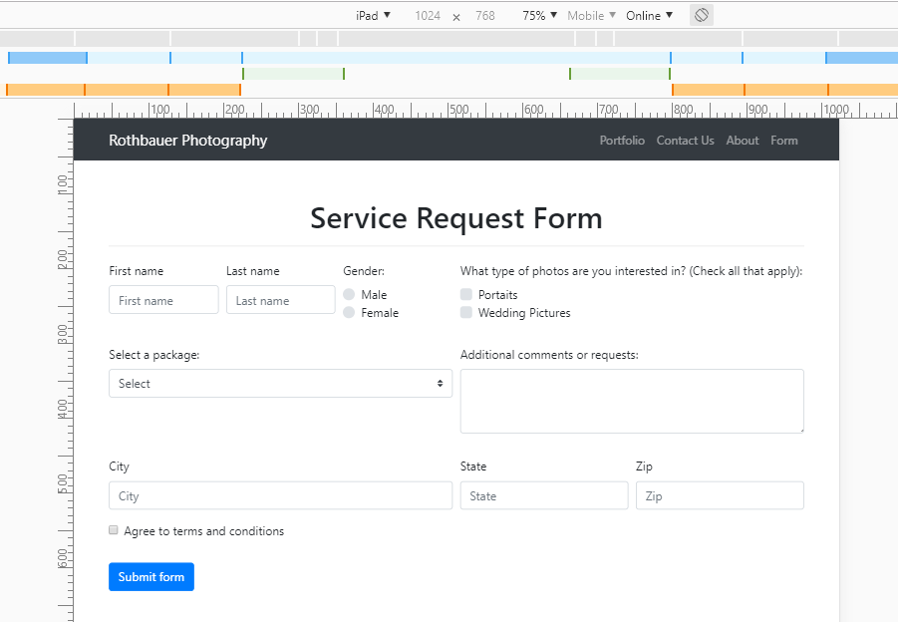

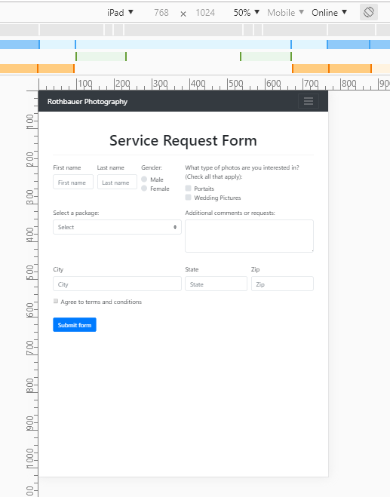

iPhone X:

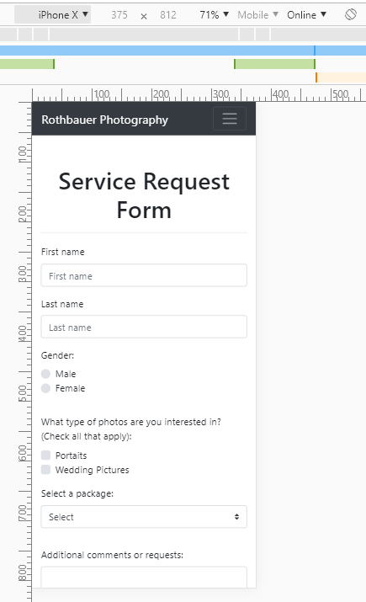

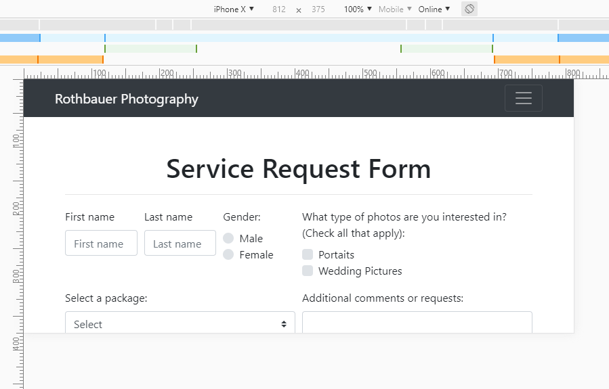

Pixel 2 XL:

